**Орнаменты казахстана - рисунки и фото**

[**Шаблоны**](https://depositphotos.com/crello.html)

[**Фотографииказахский Орнамент**](https://ru.depositphotos.com/stock-photos/%D0%BA%D0%B0%D0%B7%D0%B0%D1%85%D1%81%D0%BA%D0%B8%D0%B9-%D0%BE%D1%80%D0%BD%D0%B0%D0%BC%D0%B5%D0%BD%D1%82.html?search_params=eyJjdGYiOjEsImZbYXVkaW9dIjowfQ%253D%253D)

[**Иллюстрацииказахский Орнамент**](https://ru.depositphotos.com/vector-images/%D0%BA%D0%B0%D0%B7%D0%B0%D1%85%D1%81%D0%BA%D0%B8%D0%B9-%D0%BE%D1%80%D0%BD%D0%B0%D0%BC%D0%B5%D0%BD%D1%82.html?filter=illustration&search_params=eyJjdGYiOiIxIiwiZlthdWRpb10iOjB9)

[**Видеоказахский Орнамент**](https://ru.depositphotos.com/stock-footage/%D0%BA%D0%B0%D0%B7%D0%B0%D1%85%D1%81%D0%BA%D0%B8%D0%B9-%D0%BE%D1%80%D0%BD%D0%B0%D0%BC%D0%B5%D0%BD%D1%82.html?search_params=eyJjdGYiOjEsImZbYXVkaW9dIjowfQ%253D%253D)

[**Орнамент**](https://ru.depositphotos.com/vector-images/%D0%BE%D1%80%D0%BD%D0%B0%D0%BC%D0%B5%D0%BD%D1%82.html?search_params=eyJjdGYiOjEsImZbYXVkaW9dIjowfQ%253D%253D)

[**Казахстан**](https://ru.depositphotos.com/vector-images/%D0%BA%D0%B0%D0%B7%D0%B0%D1%85%D1%81%D1%82%D0%B0%D0%BD.html?search_params=eyJjdGYiOjEsImZbYXVkaW9dIjowfQ%253D%253D)

[**Казахские Орнаменты**](https://ru.depositphotos.com/vector-images/%D0%BA%D0%B0%D0%B7%D0%B0%D1%85%D1%81%D0%BA%D0%B8%D0%B5-%D0%BE%D1%80%D0%BD%D0%B0%D0%BC%D0%B5%D0%BD%D1%82%D1%8B.html?search_params=eyJjdGYiOjEsImZbYXVkaW9dIjowfQ%253D%253D)

[**Казахский Орнамент Вектор**](https://ru.depositphotos.com/vector-images/%D0%BA%D0%B0%D0%B7%D0%B0%D1%85%D1%81%D0%BA%D0%B8%D0%B9-%D0%BE%D1%80%D0%BD%D0%B0%D0%BC%D0%B5%D0%BD%D1%82-%D0%B2%D0%B5%D0%BA%D1%82%D0%BE%D1%80.html?search_params=eyJjdGYiOjEsImZbYXVkaW9dIjowfQ%253D%253D)

* **ЛУЧШИЙ ВЫБОР**
* [СВЕЖАЙШИЕ](https://ru.depositphotos.com/vector-images/%D0%BA%D0%B0%D0%B7%D0%B0%D1%85%D1%81%D0%BA%D0%B8%D0%B9-%D0%BE%D1%80%D0%BD%D0%B0%D0%BC%D0%B5%D0%BD%D1%82.html?sorting=newest)
* [ПОПУЛЯРНЫЕ](https://ru.depositphotos.com/vector-images/%D0%BA%D0%B0%D0%B7%D0%B0%D1%85%D1%81%D0%BA%D0%B8%D0%B9-%D0%BE%D1%80%D0%BD%D0%B0%D0%BC%D0%B5%D0%BD%D1%82.html?sorting=best_sales)

Предыдущая



[Дальше](https://ru.depositphotos.com/vector-images/%D0%BA%D0%B0%D0%B7%D0%B0%D1%85%D1%81%D0%BA%D0%B8%D0%B9-%D0%BE%D1%80%D0%BD%D0%B0%D0%BC%D0%B5%D0%BD%D1%82.html?offset=100&sh=112af5afce074efbfdfd63356f23fc68)

1-100 из 1,143

[[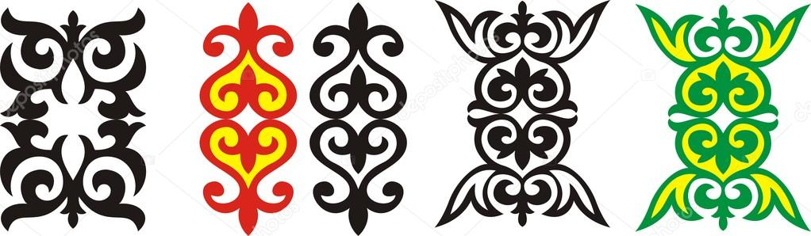](https://ru.depositphotos.com/64421269/stock-illustration-kazakh-ornament-6.html)](https://ru.depositphotos.com/64421269/stock-illustration-kazakh-ornament-6.html)

[[](https://ru.depositphotos.com/68567899/stock-illustration-kazakh-ornament.html)](https://ru.depositphotos.com/68567899/stock-illustration-kazakh-ornament.html)

[[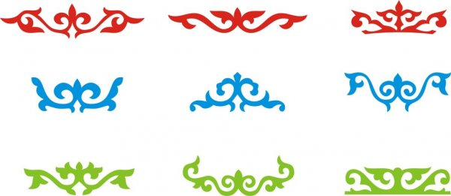](https://ru.depositphotos.com/64421279/stock-illustration-kazakh-ornament-8.html)](https://ru.depositphotos.com/64421279/stock-illustration-kazakh-ornament-8.html)

[[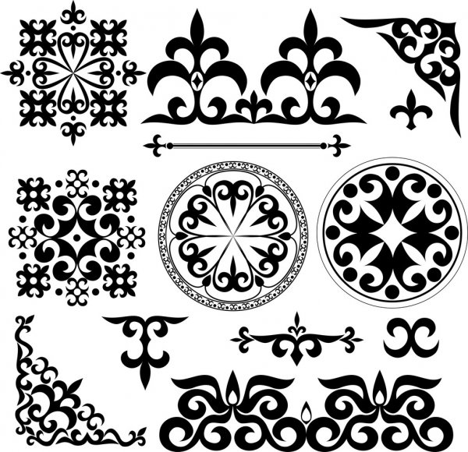](https://ru.depositphotos.com/66465007/stock-illustration-kazakh-patterns.html)](https://ru.depositphotos.com/66465007/stock-illustration-kazakh-patterns.html)

[[](https://ru.depositphotos.com/68566279/stock-illustration-kazakh-ornament.html)](https://ru.depositphotos.com/68566279/stock-illustration-kazakh-ornament.html)

[[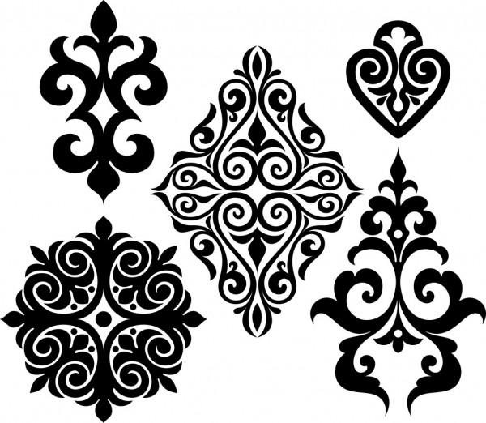](https://ru.depositphotos.com/33746875/stock-illustration-set-elements-of-ethnic-ornament.html)](https://ru.depositphotos.com/33746875/stock-illustration-set-elements-of-ethnic-ornament.html)

[[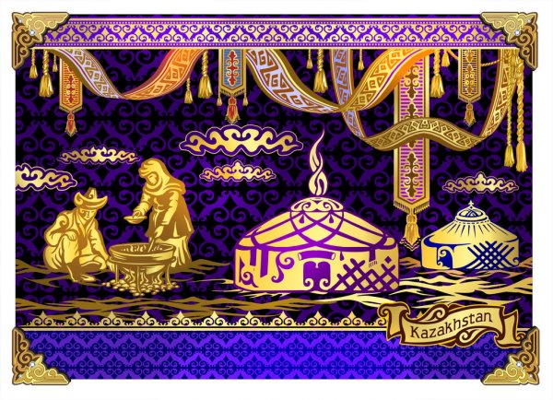](https://ru.depositphotos.com/88661850/stock-illustration-nomads-mongolian-tradition-the-kazakh.html)](https://ru.depositphotos.com/88661850/stock-illustration-nomads-mongolian-tradition-the-kazakh.html)

[[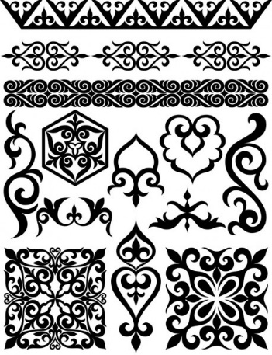](https://ru.depositphotos.com/38132913/stock-illustration-set-of-elements-of-oriental.html)](https://ru.depositphotos.com/38132913/stock-illustration-set-of-elements-of-oriental.html)

[[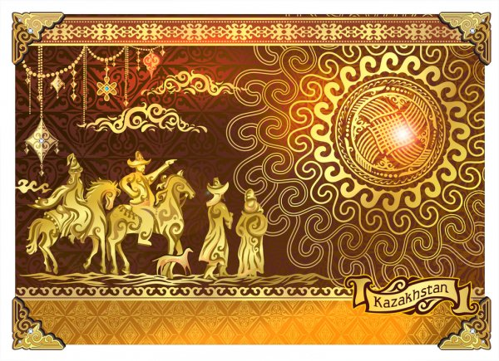](https://ru.depositphotos.com/88662122/stock-illustration-nomads-mangolskie-tradition-the-kazakh.html)](https://ru.depositphotos.com/88662122/stock-illustration-nomads-mangolskie-tradition-the-kazakh.html)

[[Концепция векторного линейного логотипа
  Векторная Графика](https://depositphotos.com/crello.html)**Шаблоны**](https://depositphotos.com/crello.html)

[[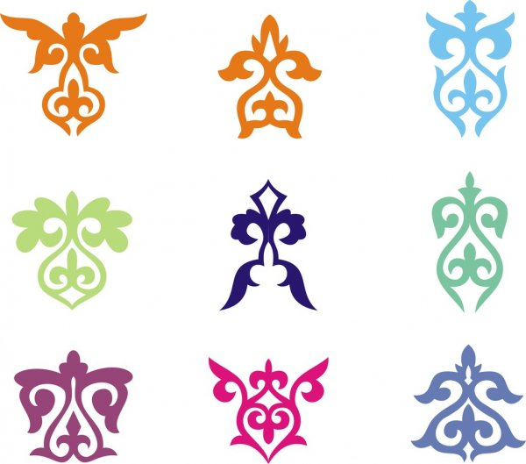](https://ru.depositphotos.com/64421273/stock-illustration-kazakh-ornament-7.html)](https://ru.depositphotos.com/64421273/stock-illustration-kazakh-ornament-7.html)

[[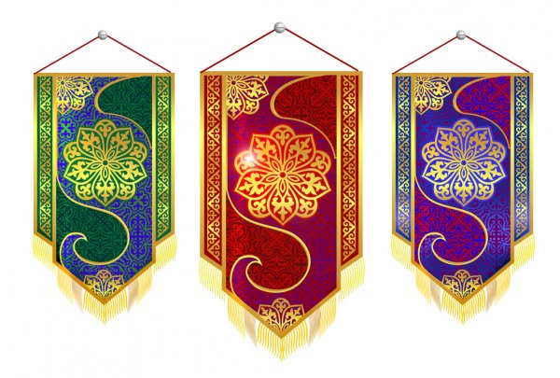](https://ru.depositphotos.com/70364457/stock-illustration-pattern-kazakh-ornament-to-national.html)](https://ru.depositphotos.com/70364457/stock-illustration-pattern-kazakh-ornament-to-national.html)

[[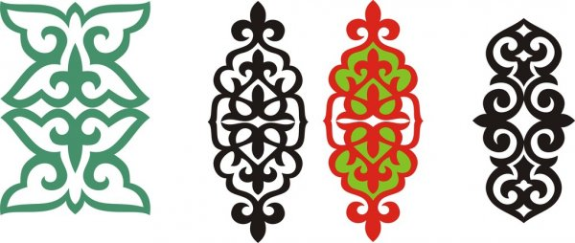](https://ru.depositphotos.com/64421265/stock-illustration-kazakh-ornament-5.html)](https://ru.depositphotos.com/64421265/stock-illustration-kazakh-ornament-5.html)

[[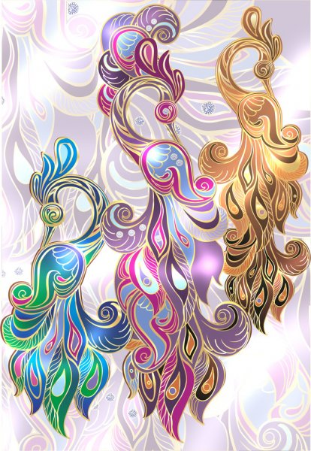](https://ru.depositphotos.com/59369929/stock-illustration-peacock-jewelry-illustration-arabian-bird.html)[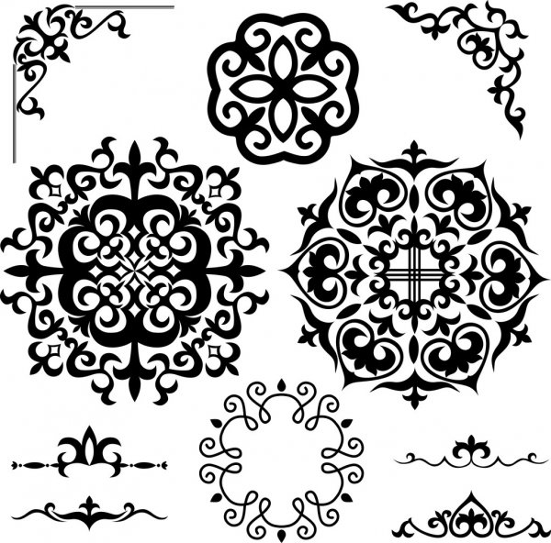](https://ru.depositphotos.com/70953783/stock-illustration-set-kazakh-asian-ornaments-and.html)](https://ru.depositphotos.com/59369929/stock-illustration-peacock-jewelry-illustration-arabian-bird.html)

[Набор казахстанских азиатских орнамен[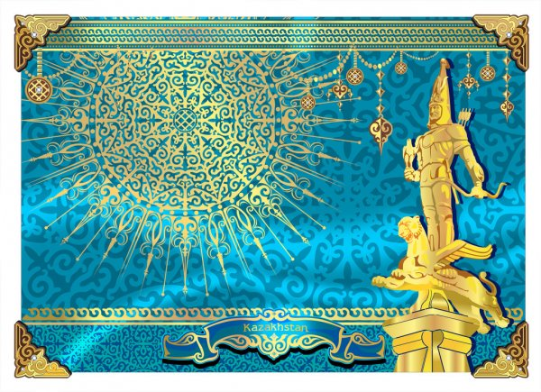](https://ru.depositphotos.com/88662814/stock-illustration-gold-man-in-republic-of.html)тов и узоров](https://ru.depositphotos.com/70953783/stock-illustration-set-kazakh-asian-ornaments-and.html)